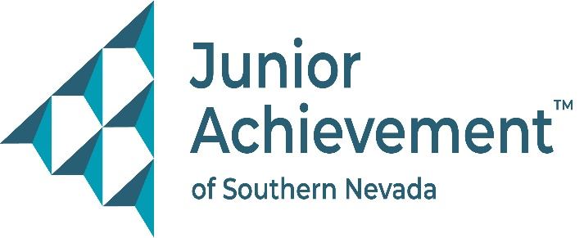

Date
FOR IMMEDIATE RELEASE:

Junior Achievement of Southern Nevada Welcomes Cox’s Indera Ramkarran
to Board of Directors



LAS VEGAS - Junior Achievement of Southern Nevada (JASN) is excited to announce the appointment of Indera Ramkarran, Digital Sales Director, West for Cox Media a division of Cox Communications, to its board of directors.

Ramkarran brings more than 15 years of experience in advertising strategy, analytics, and marketing leadership to the JASN board. Since joining Cox in 2009, she has built an accomplished career spanning multiple divisions and progressive leadership roles. In 2024, she was promoted to Digital Sales Director, West for Cox Media, where she oversees client strategy and analytics across the region.

Prior to her current role, Ramkarran served as Digital Sales Manager, National Sales Manager, and Marketing Strategist for Cox Media, as well as Senior Product Marketing Manager for Cox Business. She also held key acquisition specialist roles earlier in her career, giving her deep insight into customer engagement and growth strategies.

With primary expertise in advertising strategy and analytics, and secondary strengths in training, education, and event execution, Ramkarran brings a skill set that aligns seamlessly with Junior Achievement’s mission to prepare young people for success in work, career, and life.

“Indera’s forward-thinking mindset and strategic expertise are incredible assets to our organization,” said Michelle Jackson, JASN president and CEO. “We’re excited to welcome her to the board and look forward to the impact she will make on the future of JA programming in Southern Nevada.”

Ramkarran previously served on the board of The Shade Tree, demonstrating her commitment to supporting impactful nonprofit work in the community. She holds a Bachelor of Arts in Communication from the University at Albany.

About Junior Achievement of Southern Nevada
Founded locally in 1996, Junior Achievement of Southern Nevada, Inc. is dedicated to providing financial education to K-12 students and young adults with a curriculum including wants vs. needs, budget management to economic principals, workforce skills, credit and entrepreneurship. The completion of the new 40,000-square-foot Junior Achievement of Southern Nevada Inspiration Center will allow the nonprofit organization to impact more than 60,000 local youth. It is now the permanent site for capstone programs, Betty’s JA BizTown and JA Finance Park. Junior Achievement of Southern Nevada’s financial literacy mission is accomplished with the support of 285 businesses and 6,800 business role models, who help youth learn about the “business of life,” by helping bridge the gap between what youth learn in school and the real world. For more information visit https://jasnv.org/ and follow on Instagram and Facebook.

About Junior Achievement USA® (JA)
Junior Achievement is education for what’s next. As a strategic partner working in collaboration with educators, employers, investors, leaders, and the communities they serve, we are dedicated to helping students achieve academically today and economically tomorrow. As a leader in experiential learning operating on a national scale with over a century of experience, we are driving toward lasting change. This means ensuring a generation of students has the transferable skills and competencies needed to navigate a rapidly changing world. By delivering career-connected learning, we are invested in
accelerating economic mobility through education. By helping students become confident, capable, and connected today, we can ensure they have access to opportunity-filled futures tomorrow. Junior Achievement reaches more than 4.6 million students annually across nearly 100 U.S. markets, and is part of JA Worldwide, which serves over 19.9 million students in more than 100 countries. Learn more at www.ja.org.
# # #
MEDIA CONTACT:
Michele Voelkening Purdue Marion & Associates, 702-610-4064 or Michele@purduemarion.com

